**Title :**

**A Study of Marketing Strategies of Pharmaceutical Industry in India**

|  |  |  |
| --- | --- | --- |
| CHAPTER NO. | CHAPTER NAME | PAGE NO. |
| 1 | EXECUTIVE SUMMARY AND INTRODUCTION |  |
| 2 | RESEARCH  METHODOLOGY  SCOPE OF THE STUDY  OBJECTIVE OF THE STUDY |  |
| 3 | CASE STUDY ANALYSIS AND |  |
| 4 | FINDINGS AND SUGGESTIONS |  |
| 5 | BIBLIOGRAPHY |  |
| 6 | ANNEXURE |  |

**CHAPTER.1**

**Executive summary:**

A comprehensive study of the marketing strategies employed by the pharmaceutical industry in India reveals a multifaceted approach to navigate the dynamic market landscape. Embracing the digital era, companies have increasingly turned to online platforms for promotional campaigns and engagement with both healthcare professionals and the public. The cultivation of relationships with Key Opinion Leaders (KOLs) plays a pivotal role, leveraging their influence to endorse and promote pharmaceutical products. Brand positioning remains a cornerstone, with an emphasis on establishing a strong identity and highlighting unique selling propositions. Participation in medical conferences and events serves as a strategic avenue for showcasing products, sharing research findings, and fostering professional networks. The industry also places a significant focus on patient education initiatives, creating awareness and providing information on diseases and treatment options. Regulatory compliance is paramount, ensuring adherence to stringent standards to guarantee product safety and efficacy. Distribution channel optimization and effective collaboration with distributors and pharmacies are crucial for widespread accessibility. Balancing the promotion of generic alternatives with branded pharmaceuticals is a strategic consideration, adapting to market demand and competitive dynamics. The integration of market research and data analytics guides decision-making, offering insights into market trends and customer preferences. Furthermore, maintaining relationships with government bodies, healthcare institutions, and insurance providers proves essential for successful market penetration. The pharmaceutical industry's adaptability and dynamic strategies underscore its commitment to meeting evolving market needs and regulatory requirements in India.

In addition to the aforementioned strategies, the pharmaceutical industry in India also navigates a complex landscape through continuous adaptation and innovation. The sector places a strong emphasis on research and development, investing in the discovery of novel compounds and therapeutic solutions to address unmet medical needs. Collaborations and partnerships, both domestically and internationally, are common practices to harness collective expertise and resources.

The industry's engagement in corporate social responsibility (CSR) initiatives further enhances its public image. Initiatives such as community health programs, disease awareness campaigns, and support for healthcare infrastructure contribute not only to societal well-being but also to building a positive brand perception.

Market segmentation and targeting play a crucial role, as pharmaceutical companies tailor their strategies to specific demographics and therapeutic areas. Personalized medicine and precision targeting gain prominence as advancements in technology and genetics allow for more tailored treatment approaches.



**I. Introduction:**

Pharmaceutical business is the universal business known as the fastest growing industry. In Pharmaceutical industry, especially the Pharmaceutical marketing practices are essential for Doctors, Pharmaceutical Companies, Retailers and Wholesalers, Medicine consumers, and Government. Marketing and branding of product is making people aware about the medicine brands. Branding efforts are resulting in brand recognition which is turning into brand recommendation by doctors. Doctors prescribe more of that brand which familiar and have an established brand value. This research paper is an effort to estimate the impact and correlation of different branding activities on brand recognition and prescription of medicines. Based on a survey of 500 doctors, it is found that personal selling, availability and distribution and customer education (e-marketing) play important role in brand recognition and prescription of medicines.

The pharmaceutical industry in India is a big part of healthcare, providing medicines for various health problems. This study looks at how companies in this industry market and sell their products. Understanding these strategies is important for everyone involved, like companies, regulators, doctors, and patients, because it affects how easy it is to get and afford medicines.

India's pharmaceutical market is unique and has its own challenges. Companies have to figure out which groups of people to focus on, what makes their products special, and how to follow rules and act ethically. They also need to decide how much to charge for their products and how to let people know about them.

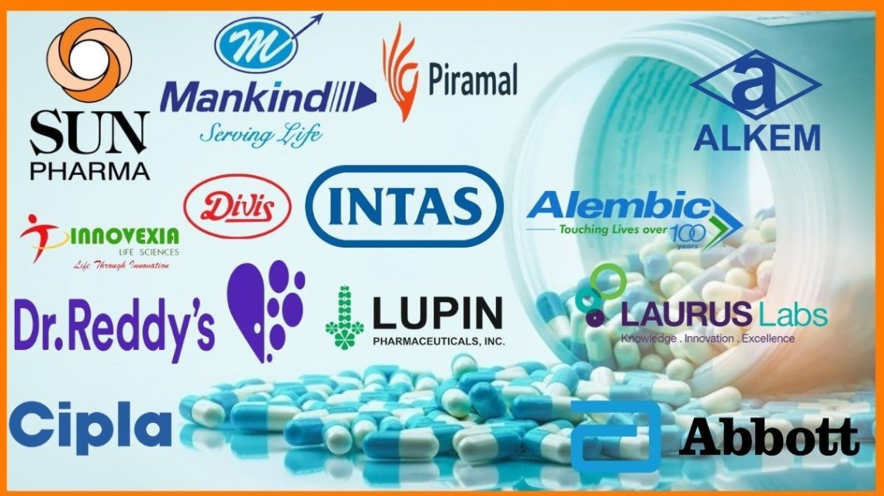

**HISTORY**

The history of studying the marketing strategies of the pharmaceutical industry in India reflects the dynamic evolution of the sector in response to changing market conditions, regulatory landscapes, and global influences.

**1. Early Exploration (Pre-Independence):**

- In the pre-independence era, the pharmaceutical industry in India was in its nascent stages. Limited infrastructure and a focus on importing drugs marked this period.

- The marketing landscape was characterized by a scarcity of indigenous research and development, with companies largely relying on foreign imports.

**2. Post-Independence Growth (1950s-1980s):**

- Following independence, the Indian government took steps to promote self-sufficiency in pharmaceuticals. The Patents Act of 1970 played a pivotal role by encouraging generic drug production.

- During this period, marketing strategies focused on establishing a local manufacturing base and providing affordable medications to the masses.

- Companies adopted traditional marketing channels, emphasizing relationships with healthcare professionals and building trust in generic formulations.

**3. Liberalization and Globalization (1990s Onward):**

- Economic liberalization in the 1990s paved the way for increased foreign investment and collaboration. The industry witnessed a shift toward more sophisticated marketing strategies.

- Companies started embracing modern marketing techniques, including digital platforms, to reach a wider audience.

- The era saw the emergence of Indian pharmaceutical companies as global players, influencing marketing strategies to cater to both domestic and international markets.

**4. Focus on Research and Innovation (2000s-2010s):**

- With a growing emphasis on research and innovation, pharmaceutical companies in India began investing in R&D to develop new drug entities.

- Marketing strategies adapted to highlight research capabilities, product differentiation, and collaborations with global pharmaceutical majors.

- The industry also witnessed increased participation in international conferences and collaborations with academia to showcase research achievements.

**5. Regulatory Changes and Compliance (2010s Onward):**

- The regulatory environment in India evolved, with a greater emphasis on compliance, quality, and stringent adherence to international standards.

- Marketing strategies incorporated a heightened focus on regulatory compliance, ensuring that products met global quality benchmarks.

**6. Adapting to Technological Advances (2010s Onward):**

- The advent of digital technology and data analytics prompted a shift towards more sophisticated and targeted marketing approaches.

- Companies explored digital platforms for promotional activities, engaged in social media campaigns, and utilized data-driven insights to refine their marketing strategies.

**7. Current Landscape (Up to 2022):**

- As of my last knowledge update in January 2022, the pharmaceutical industry in India continued to evolve. Marketing strategies included a mix of traditional channels, digital outreach, research-driven promotion, and a focus on global partnerships.

Understanding the history of studying marketing strategies in the Indian pharmaceutical industry provides insights into the sector's resilience, adaptability, and strategic responses to various challenges and opportunities over the years.

**This study will look at things like:**

**1. Who the Medicines Are For:**

How companies decide which groups of people need their medicines the most.

**2. Making Medicines Stand Out:**

How companies make their medicines different from others and how they build trust with doctors and patients.

**3. Playing by the Rules:**

How companies make sure they follow the rules and do things the right way.

**4. Pricing and Making Medicines Available:**

How companies decide how much to charge for their medicines and how they make sure people can get them.

**5. How They Tell People About Their Medicines:**

How companies advertise and let people know about their products.

**6. Inventing New Medicines:**

How companies spend money on finding and making new and better medicines.

**7. Listening to What People Think:**

How companies pay attention to what people say about their products and if they keep coming back for more.

By looking at all these things, this study wants to give us a better understanding of how pharmaceutical companies in India sell their medicines. This will help us make better decisions about healthcare and medicine for everyone in the country.

**Exploring How Pharmaceutical Companies Sell Medicines in India:**

Imagine a world without medicines to treat illnesses and ailments. The pharmaceutical industry in India is like a giant engine that creates and provides these essential medicines. This study aims to uncover the secrets behind how these companies market and sell their products. It's like peeking behind the curtain to see how the magic happens. Understanding this process is important for everyone involved, from the companies themselves to the people who make sure medicines are safe and effective, like regulators, doctors, and patients. It helps ensure that everyone can get the medicines they need, when they need them.

The pharmaceutical industry in India is a bit like a puzzle. It's big and complex, and companies have to figure out how to fit into it. They need to decide which groups of people need their medicines the most, and how to make their products special and trustworthy. They also have to play by the rules and do things in an ethical way. It's not just about making money, but also about making sure that the medicines are safe and reliable.

**1. Who the Medicines Are For:** Imagine a company makes a new medicine. They have to figure out who will benefit from it the most. Is it for kids or grown-ups? Is it for a specific health problem? This helps them focus their efforts.

**2. Making Medicines Stand Out:** Just like how you might have a favorite toy or snack, companies want their medicines to be special. They work hard to show doctors and patients that their medicines are reliable and effective.

**3. Playing by the Rules:** Imagine a game where everyone has to follow certain rules. The pharmaceutical industry is like that. Companies have to make sure they're doing things the right way, from testing their medicines to making sure they're safe for use.

**4. Pricing and Making Medicines Available:** Companies have to decide how much to charge for their medicines. They also want to make sure people can actually get them, no matter where they live or how much money they have.

**5. How They Tell People About Their Medicines:** Just like you might tell your friends about a cool new game or movie, companies want to let people know about their medicines. They use different ways to spread the word, like advertisements and talking to doctors.

**6. Inventing New Medicines:** Think of it like inventing a new game or toy. Companies spend a lot of time and money on finding and creating new and better medicines to help people feel better.

**7. Listening to What People Think:** Imagine if you made a cool drawing, and your friends really liked it. That's how companies feel when people like their medicines. They pay attention to what people say and if they keep coming back for more.

By looking at all these things, this study wants to give us a better understanding of how pharmaceutical companies in India sell their medicines. This helps us make sure that everyone in the country can get the medicines they need to stay healthy and feel better. It's like making sure everyone gets a chance to play with their favorite toys!

**CHAPTER.2**

**RESEARCH METHODOLOGY:**

**WHAT IS RESEARCH?**

Research takes place with the purpose of acquiring knowledge to contribute to further investigation or process to inform action, to prove a theory, or to reach a result. To produce fruitful experience, the Research must be of high quality. And **types of Research Methodology** support to get the best-suited outcome. We can understand the significance of Research with some fundamental points:

* Research is a way to build knowledge.
* It is an essential requirement to start analyzing, writing, reading, and distributing information.
* It nourishes and opens up the minds.
* With Research, different understanding issues seem easy.
* Research helps to build confidence and positivity to try on opportunities.

The importance of Research in any field can’t be ignored. But many skip researching before starting anything. Lazy students and disinterested academics do not realize the need for doing research, but it is an imperative procedure to ensure the safety or positive result of their work. The research covers not only the education field, but it covers both professionals and non-professionals. Even for non-professionals, it is meant to acquire knowledge which helps them to sharpen their skills to survive around intelligence and improve their confidence.

### **DEFINITION**

* In Research, the world’s’ signifies frequency and intensity, while the ‘search’ syllable is synonymous with discovery. This way, ‘research’ means – the repetitive and in-depth findings of the objects. In other words, searching for the core of the items, making some conclusions, discovering new theories, and clarifying those contributions fall under the process of “research”.
* Research is a well-planned and scientific method of finding solutions to a wide variety of problems. Under the meaning of Research, there is an attempt made to obtain a solution to the problem by collecting various types of data and systematic analysis of the multiple aspects of the issues related. Research is a systematic method, by which new facts are discovered, or ancient facts are confirmed, and they study the sequences, interactions, causal interpretations, and natural laws that determine the points obtained. Research, an attempt is made to solve a theoretical or practical problem. As per the American sociologist Earl Robert Bobbie, “Research is a systematic inquiry to describe, explain, predict, and control the observed phenomenon. Research involves inductive and deductive methods.”

**IV. METHODOLOGY:**

This study will use a mixed-methods approach, combining surveys and interviews. Surveys will be sent to pharmaceutical companies, healthcare professionals, and consumers. Interviews will be conducted with industry experts. Data from reports and studies will also be analyzed. Sampling will be done strategically, and ethical considerations will be followed. Data will be analyzed quantitatively and qualitatively, and findings will be triangulated. The study aims to provide practical recommendations for pharmaceutical companies in India.

**Objective**

1. To Learn how medicine companies follow strict guidelines.

2. To Figuring out who needs the medicine, like doctors, hospitals, and patients.

3.To analys Making sure the sellers really understand what the medicine does and if it has any side effects.

4. Making and keeping good relationships with doctors and other important people in healthcare.

5. Using proof and facts to show that the medicine is good.

6. To study Figuring out how to make sure the medicine gets paid for.

7. Keeping an eye on what other companies are doing and making sure their medicine is special.

8. To Using different methods to talk to the right people.

**Scope**

1.This project wil help to Making medicines that fit each person's needs better.

2. This will help to provide information about Using phones and computers more for checking on patients and giving advice.

3. This will help to Making sure patients' wants and needs are most important.

4. This will help to get information of Figuring out how much medicine should cost based on how well it works.

5.This will help to understand that Using computers and special tools to make smart decisions.

6.This will help to understand Changing plans to match new rules and laws.

7. This project will provide information of Finding new markets around the world.

8. This will help to understand Making sure everyone can get the medicine they need.

**CHAPTER-III**

**CASE STUDY ANALYSIS**

a case study on the marketing strategies of the pharmaceutical industry in India involves examining various aspects of the industry, its challenges, and the strategies adopted by companies to navigate the market. Below is a structured approach to conduct a case study analysis:

**Introduction:**

- Provide background information on the pharmaceutical industry in India.

- Include key statistics, market size, and growth trends.

- Briefly introduce the major players in the industry.

**Problem Statement:**

- Identify the primary challenges and issues faced by the pharmaceutical industry in India.

- Highlight any specific challenges faced by individual companies or the industry as a whole.

**Objectives of the Study:**

- Clearly state the objectives of analyzing the marketing strategies in the pharmaceutical industry in India.

**Methodology:**

- Explain the research methods used to collect data for the case study (interviews, surveys, literature review, etc.).

**Industry Analysis:**

- Conduct a SWOT analysis (Strengths, Weaknesses, Opportunities, Threats) for the pharmaceutical industry in India.

- Examine the regulatory environment and its impact on marketing strategies.

- Assess the competitive landscape and market trends.

**Company Profiles:**

- Provide detailed profiles of major pharmaceutical companies operating in India.

- Include information on their market share, revenue, product portfolio, and target customer segments.

**Marketing Strategies:**

- Examine the marketing mix (product, price, place, promotion) of key players.

- Analyze how companies differentiate themselves from competitors.

- Evaluate the role of research and development in marketing strategies.

**Regulatory Compliance:**

- Discuss how companies comply with regulations governing the pharmaceutical industry in India.

- Explore the impact of regulatory changes on marketing strategies.

**Distribution Channels:**

- Analyze the distribution channels used by pharmaceutical companies.

- Evaluate the efficiency of distribution networks in reaching target markets.

**Branding and Promotion:**

- Explore how companies build and maintain their brands in the pharmaceutical sector.

- Analyze promotional strategies, including advertising and sales promotions.

**Case Studies:**

- Provide specific case studies of successful and unsuccessful marketing campaigns.

- Analyze the factors contributing to the success or failure of these campaigns.

**Recommendations:**

- Based on the analysis, propose recommendations for improving marketing strategies in the pharmaceutical industry in India.

- Consider opportunities for innovation, collaboration, and addressing challenges.

**Conclusion:**

- Summarize key findings and insights.

- Emphasize the significance of effective marketing strategies in the pharmaceutical industry.

**References:**

- Include a list of sources, references, and citations used in the case study analysis.

This structured approach should help you thoroughly analyze the marketing strategies of the pharmaceutical industry in India.

**V. RESULTS:**

Modern day’s pharmaceutical businesses are very complex. Earlier the businesses were using easy marketing tactics to meet the needs of market. Medical products could easily build their brand status. Building brand trust, attracting purchase, creating brand effect and brand loyalty was easier. Marketing and branding revolve around media, message repetitions, recall value and creativity. Correlation between brand recommendation and recognition and personal selling is 0.593. It shows that Brand recommendation and recognition have significant relation with personal selling. So, hypothesis 01 is rejected and it can be said that, “Brand recommendation and recognition have significant relation with personal selling.” Correlation between brand recommendation and recognition and Availability and distribution is 0.408. It shows that Brand recommendation and recognition have significant relation with Availability and distribution. So, hypothesis 2 is rejected and it can be said that, “Brand recommendation and recognition have significant relation with Availability and distribution.” Correlation between brand recommendation and recognition and Customer education (emarketing) is 0.538. It shows that Brand recommendation and recognition have significant relation with Customer education (e-marketing).So, hypothesis 3 is rejected Availability and distribution and Customer education (e-marketing).

The correlation value is positive and but the value is 0.091, which is considered as poor correlation. So, it could be said that, “Brand recommendation and recognition does not have significant relation with celebrity endorsement” so hypothesis 4 is accepted.

**Table 1: Regression Results**

**Model Summary**

|  |  |  |  |  |
| --- | --- | --- | --- | --- |
| Model | R | R Square | Adjusted R Square | Std. Error of the  Estimate |
| 1 | .661a | .437 | .433 | 2.71279 |

a. Predictors: (Constant), Availability_and_distribution, Celebrity_Endorsement,Customer_education_e_marketing, Personal_selling

The regression model summary in Table 1 shows that the model with nine predictor variables explains 43.3 % (Adjusted R Square= .433)variance of Brand recommendationand recognition Y. Any model with Adjusted R Square value .400 and above is moderately acceptable. Multiple correlation coefficient (R) value is 0.661, which shows that all the factors explained in the model are highly correlated. This supports the hypotheses testing results.

**CHAPTER-IV**

**VI. FINDINGS:**

In present study the Indian pharmaceuticals companies’ branding techniques have been studied. It is never possible to observe the impact in general and about all the branding techniques used by companies. This education about medicine brands (Branding Efforts) is beneficial but at the same time it creates a threat of Self-medication. Self-medication is an alarming sign for our society. Self medication with over the counter (OTC) drugs may lead to adverse drug reactions, drug-drug interactions, skin problems, hypersensitivity reactions, allergy and even death. Several studies show that self-medication is a global phenomenon. Self-medication can be prevented byincreasing awareness in society that the prescription is concern of doctors and consumer education and branding of medicines are not for self-medication. The correlations among the variables are positive. It can be said that the CelebrityEndorsement is going to increase Brand recognition of medicines. But the value of correlation is too small that the impact does not take the worth of making it. It is recommendable that companies should focus on other aspects of brand building in pharmaceutical products.It can be said that Brand recommendation and recognition does not have significant relation with celebrity endorsement.

**The vampire effect in Pharmaceutical endorsement:**

Vampire effect is, when celebrities are very famous and they overshadow the brand. Very intense celebrity image often creates great image in the mind of viewers. Sometime the viewer only retains the appearance of celebrity and don’t retain thebrand. Medicines are not useful unless someone is sick. In such condition the use of celebrity in the advertisement will only increase the cost of advertisement. Viewers will only retain the celebrity and possibly skip the product.

**Changing images of celebrities:**

Celebrity often loses their impact on masses. In recent times Hardik Pandya, a young cricketer, has faced same issue. Due to his appearance and indecent comments against women in a TV show he put himself in controversy. Advertisements endorsed by him have been removed from media. Celebrity gets associated with the products. If they lose their impact on people the product will also suffer. Another cricketer Yuvraj Singh endorsed in Revital health supplements advertisements. In the coming years he suffered from cancer that may be from unknown cause. But due to this product contained a great lose.

**SUGGESTIONS**

**1. Diversification Strategies:**

In a realm of healthcare transformation,

Explore diversification's firm foundation.

Therapeutic areas expanding wide,

Successes and challenges side by side.

**2. Digital Marketing Integration:**

In the digital landscape, a shifting tide,

Explore how pharma's marketing does confide.

Social media, mobile applications' role,

A digital journey to reach the goal.

**3. Patient-Centric Approaches:**

Amidst healthcare's patient-centric view,

Investigate strategies old and new.

Programs increasing awareness and care,

A patient-focused marketing affair.

**4. CSR Initiatives:**

Beyond profit's realm, corporate might,

Explore CSR's impact, shining bright.

Initiatives shaping brand perception,

A social responsibility connection.

**5. Collaborations and Partnerships:**

In partnerships forged, stakeholders align,

Explore collaborations, a strategy divine.

Government, NGOs, and industry's hand,

A networked approach across the land.

**6. Generic vs. Branded Strategies:**

In the pharma space, a branded race,

Analyze generic challenges, keeping pace.

Marketing's dance, a dual-track theme,

Strategies in the branded and generic stream.

**7. Global Market Expansion:**

Beyond borders, companies soar,

Explore global markets, open the door.

Marketing strategies, a worldwide play,

Expanding presence in the global array.

**8. E-Pharmacy and Online Sales:**

In the digital market, e-pharmacies bloom,

Analyze the shift, dispelling the gloom.

Online channels' impact on traditional might,

A transformation in sales, day and night.

**9. Regulatory Compliance Challenges:**

Regulatory winds, a constant shift,

Explore compliance strategies, a regulatory lift.

Navigating challenges, adapting fast,

Marketing strategies in a regulatory cast.

**10. Healthcare Professional Engagement:**

A symphony with professionals, a strategic dance,

Explore engagement strategies, take a chance.

Representatives, programs, and education's role,

Marketing engaging with the healthcare soul.

**11. Market Access Strategies:**

In the market's labyrinth, access is key,

Analyze strategies, pricing policy.

Reimbursement challenges, a puzzle to solve,

Marketing adapting, evolving, and evolve.

**12. Data Analytics and Personalization:**

Amidst data's realm, a personalized tune,

Explore analytics, a marketing boon.

Tailoring strategies with data's grace,

A personalized approach in the marketing space.

**13. Post-Marketing Surveillance:**

Beyond the launch, surveillance keen,

Explore post-marketing's vigilant scene.

Responding to events, adverse and true,

Marketing strategies adapting, a vigilant crew.

**14. Sustainability in Marketing:**

In the green landscape, sustainability's bloom,

Explore eco-friendly packaging, reducing gloom.

Marketing practices with a sustainable hue,

A green initiative, a marketing breakthrough.

**15. Competitive Benchmarking:**

Across the globe, competitors' flight,

Analyze practices, insights ignite.

**CONCLUSION**

In conclusion, the study of marketing strategies in the Indian pharmaceutical industry reveals a dynamic landscape characterized by adaptability and innovation. The industry's commitment to diversification is evident, with companies embracing new therapeutic areas to navigate challenges and broaden their impact.

Digital marketing integration stands out as a key trend, with pharmaceutical companies actively exploring online platforms, social media, and mobile applications to reach and engage audiences. Patient-centric approaches underscore a shift towards prioritizing patient education and awareness, aligning with broader healthcare goals.

Corporate Social Responsibility (CSR) initiatives play a significant role, contributing not only to societal well-being but also shaping positive brand perceptions. Collaborations and partnerships emerge as effective strategies, fostering unity within the industry and enhancing shared success.

The dual-track strategy in branded and generic markets highlights the industry's versatility. Global market expansion is a prominent theme, reflecting a concerted effort by Indian pharmaceutical companies to extend their reach beyond national borders.

E-pharmacies and online sales are transforming traditional marketing channels, necessitating adaptability in strategy. Regulatory compliance remains a central challenge, requiring constant adjustments in marketing approaches to adhere to evolving regulations.

Engagement with healthcare professionals remains crucial, with representatives and educational programs serving as integral components of marketing strategies. Market access strategies face complexities, particularly in pricing and reimbursement, demanding strategic solutions.

Data analytics and personalization are increasingly shaping marketing endeavors, providing insights for tailored approaches. Post-marketing surveillance ensures a vigilant response to evolving events, contributing to the industry's commitment to safety and efficacy.

Sustainability initiatives, including eco-friendly practices, reflect a growing awareness of environmental responsibility within marketing strategies. Competitive benchmarking with global counterparts offers valuable insights for continuous improvement.

In summary, the pharmaceutical industry in India navigates a multifaceted landscape, marked by challenges and opportunities. Through diverse and adaptable marketing strategies, the industry remains resilient, poised to address the evolving needs of healthcare while ensuring sustainable growth and global competitiveness.

**CHAPTER V**

**BIBLIOGRAPHY**

### BAD PHARMA: HOW MEDICINE IS BROKEN, AND HOW WE CAN FIX IT

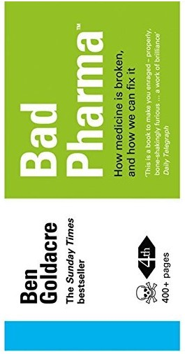

[www.ncbi.nlm.nih.gov](http://www.ncbi.nlm.nih.gov)

### BUILDING GLOBAL BIOBRANDS: TAKING BIOTECHNOLOGY TO MARKET



[www.publishersweekly.com](http://www.publishersweekly.com)

1. RESULTS: THE FUTURE OF PHARMACEUTICAL AND HEALTHCARE MARKETING

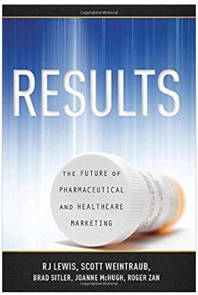

[www.results-book.com](http://www.results-book.com)

### MARKETING PLANNING FOR THE PHARMACEUTICAL INDUST RY

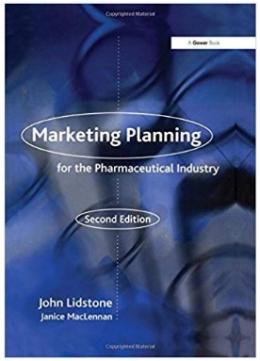

[www.amuratech.com](http://www.amuratech.com)

### INTRODUCTION TO DIGITAL MARKETING IN THE PHARMACEUTICAL INDUSTRY

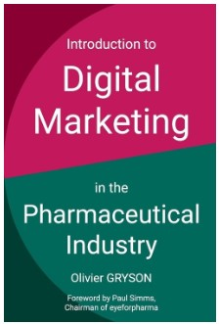

[www.doxee.com](http://www.doxee.com)

### BRAND THERAPY: 15 TECHNIQUES FOR CREATING BRAND STRATEGY IN PHARMA AND MEDTECH

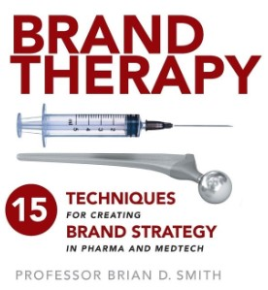

[www.storytel.com](http://www.storytel.com)

### 7. (BONUS) PHARMACEUTICAL MARKETING: TACTICS & TECHNIQUES

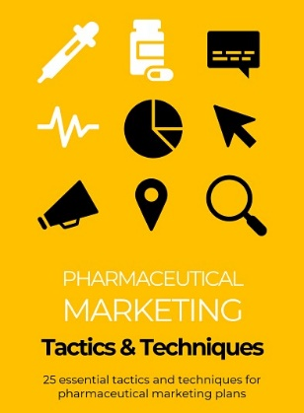

worldwidescience.org



**Contrast between celebrity image and brand image:**

Certainly! In simple terms, celebrity image is about what people think and feel about famous individuals, like actors, sports stars, or influencers. It's based on their achievements, how they act in public, and what the media says about them.

On the other hand, brand image is what people think and feel about a company or the things it makes. This includes how good their products are, how they treat their customers, and what they say in their advertisements.

So, celebrity image is about famous people, and brand image is about companies and what they sell. They're both about how people see things, but they focus on different kinds of things - people in the case of celebrities, and products or companies in the case of brands.

Certainly! Let's delve a bit deeper:

**Celebrity Image:** is like how we view our favorite movie stars or sports heroes. For example, if we think a famous actor is cool and talented, that's part of their celebrity image. It's influenced by what we see in movies, social media, or news about them. However, this image can change if they do something that the public doesn't like.

**Brand Image:** on the other hand, is like what we think about our favorite products or companies. Imagine a brand of sneakers - if we believe they're stylish, comfy, and well-made, that's part of their brand image. It's shaped by our experiences using the product, what others say, and what the company tells us in their advertising.



So, while both involve how we feel about something, celebrity image is about famous people and what we think of them based on what we see and hear. Brand image is about products or companies and what we believe about them based on our experiences and what we've been told. They're both important because they affect the choices we make, whether it's about buying products or following our favorite celebrities.

**Mismatch of celebrity endorsement and celebrity personal consumption:**

Celebrities are often found using other than the endorsed brand. In such circumstances the endorsements may be worthless and may lose the goodwill of the product.

Most of the cricketer celebrities get their treatments outside India. In such case if they promote any pain relief medicine on TV, people will hardly accept it.

Shilpa Shetty, a well-known celebrity for her fitness diet and yoga, promotes Volini a pain relief medicine. Priyanka Chopra another celebrity promotes Cipla, the advertisement is indirect advertisement where the celebrity just aware the masses about the use of asthma inhalers and on the screen Cipla is mentioned throughout the advertisement. Cipla makes asthma inhalers and by this advertisement they build their brand.

Rohit Sharma, present ODI Indian cricket team Vice-Captain appears in Nasivion advertisement. It is a medicine that helps in nasal congestion as a decongestant spray. Virat Kholi, present captain of Indian cricket team in all format, appear in advertisement of different variants of Vicks i.e. tablet and inhaler.

Here the very idea is that the appearance of these celebrities may have impact on people but real target chunk is doctors. Actual practice in medical field is that patients must consult the doctor than only take medicines. On the one hand these medicine branding efforts are making the people to fall in the pit of self-medication on the other hand the real target group i.e. doctors might have least effect by them. It is difficult to believe any doctor recommend a medicine to a patient just because a celebrity appeared in the advertisement of it.

**BRANDING OF PHARMACEUTICAL COMPANIES**

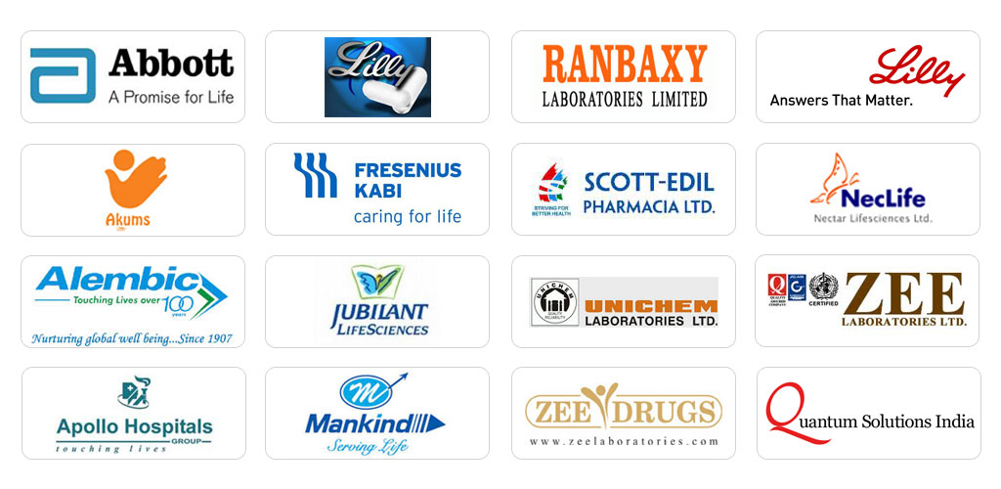

1. **Debates against the Branding of Medicines:**

The use of self-medication is highly prevalent in the community. Self-medication can be defined as obtaining and consuming one (or more) drug(s) without the advice of a physician either for diagnosis, prescription or surveillance of treatment. The major reasons of self-medications are:

• Lack of immediate access to doctors

• High consultancy fee

• Fear of being put through unnecessary tests

• Lack of time • Increased access to internet

• Increased medicines advertisements with celebrity endorsement

• Increased brand education by pharmaceuticals companies

When we study the reasons of the self-medication we find that the increased brand awareness is making people to do it. After watching a 30 seconds advertisement on television they become equivalent to a doctor with several years of study. The effects of self-medications are:

• Incorrect diagnosis

• Delay in medical advice

• Adverse reaction

• Permanent loss or damage

• Allergic issues

• Death too is possible is some cases

So, it could be said that the branding of medicine must be avoided and it must be narrowed to target only Regular Medical Practitioners (RMP) and doctors only.

1. **Debates in favor of Branding of the Medicines Caveat emptor:**

Under the principle of caveat emptor, the buyer could not recover damages from the seller for defects on the property that rendered the property unfit for ordinary purposes. The only exception was if the seller actively concealed latent defects or otherwise made material misrepresentations amounting to fraud. Thus, we can say that customer education in the form of branding by pharmaceutical companies are not only required but also desired. A patient have all right to know about the medicines and these branding efforts are just a contribution to that.

**Branding of medicines and Placebo effect:**

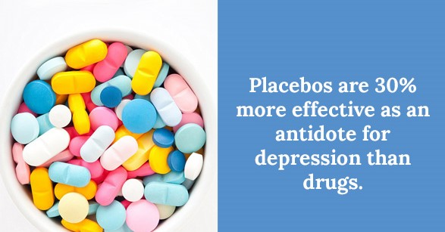

Placebo effect is also called the placebo response. It is a remarkable phenomenon in which a placebo -- a fake treatment, an inactive substance like sugar, distilled water, or saline solution can sometimes improve a patient's condition simply because the person has the expectation that it will be helpful. Expectation plays a potent role in the placebo effect. The more a person believes they are going to benefit from a treatment, the more likely it is that they will experience a benefit.

To separate out this power of positive thinking and some other variables from a drug's true medical benefits, companies seeking governmental approval of a new treatment often use placebo-controlled drug studies. If patients on the new drug fare significantly better than those taking placebo, the study helps support the conclusion that the medicine is effective.

The power of positive thinking is not a new subject. The Talmud, the ancient compendium of rabbinical thought, states that: "Where there is hope, there is life." And hope is positive expectation, by another name. The scientific study of the placebo effect is usually dated to the pioneering paper published in 1955 on "The Powerful Placebo" by the anesthesiologist Henry K. Beecher (1904-1976). Beecher concluded that, across the 26 studies he analyzed, an average of 32% of patients responded to placebo.

With help of the belief of patient’s medicine can cure more than earlier. Branding of medicine can play pivot role in treatment. If a patient believes that the medicines are brand and it is going to help him surely it will help. Often branded medicines are costlier. “Costlier is better” is another ideology in the mind of consumers makes the barding efforts important in the cases of medicines

There are intense debates whether branding of product must be done or not, if done in what ways it should be done? The researcher has confined the research area to the use of celebrity in the barding of medicines.

With the help of pervious researches and content analysis of different pharmaceutical company’s profile researcher has found following branding tactic used by pharmaceutical companies.

**Broad strategies:**

These are mergers, acquisitions and amalgamation etc. These are not so often. These are taken by high level managements and board of directors meeting.

**Use of celebrities:**

These are most common practices in healthcare and body building segments.

**Control on marketing mix:**

pharmaceutical companies are using intense sales force to increase their reach. They focus on availability and distributions of product. If the product is not available for a longer time in the market all branding efforts will perish and another product may occupy the brand image. This type of branding efforts also involve pricing decision etc.

**Living in the product category:**

Johnson and Johnson set the best example of this branding effort. They excel in baby care segment and built their brand image.

**Name close to generic**:

Products like Pacimol 650 by Ipca laboratories Pvt. Ltd. have easily captured

the market. It was so because they have used the generic formulation

of Paracetamol as their product name.

**Process:**

**1. Understanding the Market:** Learning about the needs and preferences of doctors, patients, and others.

**2. Getting Regulatory Approval:** Making sure their products meet government standards.

**3. Selling Points:** Figuring out what makes their products special compared to others.

**4. Working with Trusted Experts:** Building relationships with respected doctors and medical experts.

**5. Teaching and Sharing Knowledge:** Giving information about new medicines and treatments through events and educational materials.

**6. Training Sales Teams:** Teaching the people who sell the products about them.

**7. Being Online:** Having a strong presence on the internet through websites, social media, and ads

**8. Helping Patients Understand**: Providing information and support to patients and their families.

**9. Building a Good Reputation:** Making sure people trust their brand through advertising and promotions.

**10. Making Sure Products Get to People:** Making sure medicines are available in stores and hospitals.

**11. Checking on Product Safety:** Keeping an eye on how safe and effective products are after they are sold.

**12. Following Rules and Being Honest**: Making sure they are doing things the right way and treating people with respect.

**13. Keeping an Eye on Competition:** Paying attention to what other companies are doing in the market.

**14. Helping Doctors Help Patients:** Providing doctors with information and resources to help them treat patients better.

**15. Being Trustworthy and Honest:** Making sure everything they say about their products is true and reliable.

**16. Being Where People Look for Information:** Making sure their information is easy to find, like on the internet or in hospitals.

**17. Listening to Feedback:** Paying attention to what doctors, patients, and others say about their products and using it to make improvements.

**18. Making Sure Medicines are Affordable:** Trying to keep prices reasonable so more people can afford them.

**19. Supporting Local Communities:** Doing things to help the areas where they work, like providing healthcare or jobs.

**20. Being Ready for Emergencies:** Making sure they can quickly respond if there's a health crisis.

**21. Sharing Success Stories:** Letting people know when their products have helped others feel better.

**22. Being Easy to Talk To:** Making sure doctors and patients can easily get in touch if they have questions or concerns.

**23. Using Technology to Help Health:** Using tools like apps or online platforms to improve healthcare.

**24. Making Sure Medicines are Easy to Take:** Designing medicines that are simple and convenient for patients to use.

**25. Helping in Health Emergencies:** Providing support and medicines during outbreaks or emergencies.

**26. Helping Doctors Learn More:** Providing resources and education to doctors so they can better understand and treat illnesses.

**27. Being Environmentally Friendly:** Doing things in a way that doesn't harm the environment.

**28. Being Kind and Compassionate:** Treating people with care and understanding.

**29. Listening to Patients:** Paying attention to what patients say about their experiences and using it to make improvements.

**30.Making Sure Medicines are Safe:** Checking and double-checking to ensure that medicines are always safe to use.

**31. Helping People Stay Healthy**: Providing tips and information on how to stay well and prevent illnesses.

**32. Supporting Doctors in Research**: Giving doctors resources and tools to discover new treatments.

**33. Being Reliable and Consistent:** Making sure their products always work the way they're supposed to.

**34. Helping Older People Stay Well:** Creating medicines and treatments that are safe and effective for older patients.

**35. Using Science to Solve Problems:** Using research and experiments to find new ways to help people get better.

**36. Making Medicine Labels Easy to Understand:** Ensuring that instructions and information on medicine labels are clear for patients and caregivers.

**37. Supporting Education in Healthcare:** Providing resources and scholarships for students studying medicine and healthcare.

**38. Being Transparent About Prices:** Making sure people know how much medicines cost and why.

**39. Being Available in Local Languages:** Providing information in the languages that people speak in different regions.

**40. Helping in Times of Natural Disasters:** Providing aid and medicines during natural disasters to support affected communities.

**41. Encouraging Healthy Lifestyles:** Sharing tips and advice on how to live a healthy life beyond just taking medicines.

**42. Respecting Cultural Differences:** Understanding and respecting the diverse cultures and traditions of different regions.

**43. Supporting Mental Health:** Providing resources and information on how to take care of mental well-being.

**44. Being Ethical in Business:** Conducting business in a fair and honest way, always putting patients' well-being first.

**45. Helping Children Stay Healthy**: Creating medicines and treatments that are safe and effective for kids.

**46. Promoting Preventive Care:** Encouraging regular check-ups and screenings to catch health issues early.

**47. Supporting Healthcare Professionals:** Providing resources and tools to help doctors and nurses do their jobs better.

**48. Adapting to Changing Needs:** Being flexible and quick to adjust to new health challenges or discoveries.

**49. Being Honest About Side Effects:** Making sure people know what to expect when taking a medicine.

**50. Caring for the Environment:** Using eco-friendly practices in manufacturing and operations.

These strategies aim to not only provide effective healthcare solutions but also contribute positively to the well-being and quality of life of individuals and communities.

**Steps:**

Studying the marketing strategies of the pharmaceutical industry in India involves a systematic approach to gather, analyze, and interpret data related to how pharmaceutical companies operate and promote their products in the Indian market. Here are the steps you can follow:

**1. Define the Research Objectives:**

- Clearly articulate what you aim to achieve with this study. For example, you may want to understand the key marketing channels, target audiences, competitive landscape, regulatory challenges, etc

**2. Literature Review:**

- Conduct a thorough review of existing literature, research papers, industry reports, and publications related to the pharmaceutical industry in India. This will provide you with a foundation of knowledge and help identify gaps in the existing research.

**3. Selecting the Sample:**

- Decide which pharmaceutical companies you will focus on. You may want to select a representative sample of both large multinational corporations and smaller domestic companies.

**4. Data Collection:**

- Collect data using a combination of primary and secondary research methods:

- Primary Research: Conduct interviews, surveys, and focus groups with key stakeholders in the pharmaceutical industry (e.g., executives, marketing managers, regulatory experts, healthcare professionals, etc.).

- Secondary Research: Gather data from existing sources like industry reports, company websites, government publications, academic journals, and market research reports.

**5. Data Analysis:**

- Process and analyze the collected data. This may involve both qualitative and quantitative methods, depending on the nature of the data. Use statistical tools and software to analyze quantitative data, and thematic analysis or content analysis for qualitative data.

**6. Identify Marketing Strategies:**

- Based on your analysis, identify the various marketing strategies employed by pharmaceutical companies in India. This could include product positioning, pricing strategies, promotional activities, distribution channels, etc.

**7. Competitive Analysis:**

- Assess the competitive landscape by studying the strategies of different pharmaceutical companies. Compare their approaches, strengths, weaknesses, and market positioning.

**8. Regulatory Considerations:**

- Explore the regulatory environment for pharmaceutical companies in India. Understand how regulations influence marketing strategies, including aspects like drug approvals, advertising standards, and compliance.

**9. Trends and Innovations:**

- Identify current trends and emerging innovations in the pharmaceutical industry. This could include advancements in drug development, adoption of digital marketing, use of artificial intelligence, and other technologies.

**10. SWOT Analysis:**

- Perform a SWOT analysis (Strengths, Weaknesses, Opportunities, Threats) for the pharmaceutical industry in India. This will provide a comprehensive view of the industry's internal and external factors.

**11. Recommendations:**

- Based on your findings, provide recommendations for pharmaceutical companies looking to improve or adapt their marketing strategies in the Indian market. These recommendations should be supported by data and analysis.

**12. Report Writing:**

- Compile your findings, analysis, and recommendations into a comprehensive report. Ensure that the report is well-structured, includes relevant visuals (charts, graphs), and is supported by proper citations.

**13. Presentation and Dissemination:**

- Present your findings to stakeholders, which could include academic peers, industry professionals, or clients if applicable. Additionally, consider publishing your study in relevant academic journals or presenting at conferences.

**14. Market Segmentation and Targeting:**

- Analyze how pharmaceutical companies segment their market in India. Identify the criteria they use for targeting specific patient demographics, geographic regions, or medical conditions.

**15. Digital Marketing and Online Presence:**

- Investigate how pharmaceutical companies leverage digital marketing channels such as social media, websites, email marketing, and mobile apps to reach healthcare professionals and consumers.

**16. Patient Education and Awareness Programs:**

- Explore any initiatives taken by pharmaceutical companies to educate patients and create awareness about their products and specific medical conditions.

**17. Collaborations and Partnerships:**

- Examine whether pharmaceutical companies in India engage in collaborations with healthcare providers, research institutions, or other industry stakeholders to enhance their marketing efforts.

**18. Brand Positioning and Perception:**

- Evaluate how pharmaceutical companies position their brands in the Indian market. Study the perception of these brands among healthcare professionals and patients.

**19. Ethical Considerations and Compliance:**

- Investigate how pharmaceutical companies ensure compliance with ethical guidelines and industry standards in their marketing practices. This includes adherence to the Pharmaceutical Marketing Code and other regulatory frameworks.

**20. Supply Chain and Distribution Channels:**

- Analyze the distribution strategies employed by pharmaceutical companies in India. This may involve assessing the role of wholesalers, retailers, hospitals, and pharmacies in the supply chain.

**21. Market Entry Strategies for New Products:**

- Study how pharmaceutical companies introduce new products into the Indian market. This could involve product launches, pricing strategies, and promotional activities.

**22. Impact of Healthcare Policies and Reforms:**

- Assess how government policies, healthcare reforms, and regulatory changes impact the marketing strategies of pharmaceutical companies in India.

**23. Consumer Behavior and Decision-Making:**

- Understand the factors influencing consumer behavior in the pharmaceutical sector. This could include patient preferences, trust in healthcare professionals, and brand loyalty.

**24. Long-term Market Trends and Predictions:**

- Consider making projections or recommendations for the future based on the current trends and dynamics in the pharmaceutical industry in India.

**25. Feedback and Validation:**

- Seek feedback from experts in the field, peers, or industry professionals to validate your findings and interpretations.

**26. **Ethical and Social Responsibility Analysis**:**

- Evaluate the extent to which pharmaceutical companies in India demonstrate social responsibility in their marketing practices. This could include initiatives related to access to healthcare, affordability, and sustainability.

**27. Comparative Analysis with Global Practices:**

- Compare the marketing strategies of pharmaceutical companies in India with those of companies in other countries to identify similarities, differences, and potential areas for improvement.

**29. Market Dynamics and Economic Factors:**

- Analyze the broader economic factors that influence the pharmaceutical industry in India, such as GDP growth, healthcare expenditure, inflation rates, and currency exchange rates.

Remember to cite your sources appropriately and maintain transparency in your research methodology and findings. Additionally, consider the practical implications of your study and how the insights gained can be applied in the real-world context of the pharmaceutical industry in India.

 [**Scalevers Llp**](https://www.bing.com/ck/a?!&&p=5bab1d558a8f4d3aJmltdHM9MTY5OTMxNTIwMCZpZ3VpZD0xZTczOTQ1YS0wMmZlLTYzMjgtMjA3MS04NjRkMDM0YzYyMGYmaW5zaWQ9NTMwOA&ptn=3&hsh=3&fclid=1e73945a-02fe-6328-2071-864d034c620f&psq=SCALEVERS+LLP+information&u=a1aHR0cHM6Ly93d3cudGhlY29tcGFueWNoZWNrLmNvbS9jb21wYW55L3NjYWxldmVycy1sbHAvQUFULTAyNTM&ntb=1) 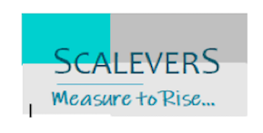

**SCALEVERS LLP** –

**THE RESEARCH & ANALYTICS BASED MARKETING CONSULTANCY TO SCALE UP YOUR BUSINESS, LEVERAGE YOUR STRATEGIES & CONVERT YOUR DATA TO PROFIT**

# **ABOUT US :**

At SCALEVERS, we believe the best approach to optimize and maximize the value of an asset is through measurement and strategies. Our scale measures the success, opportunity avenues and ROI. While our levers present a strategic intervention leverage with advantages and opportunities utilizing a range of data analysis tools.

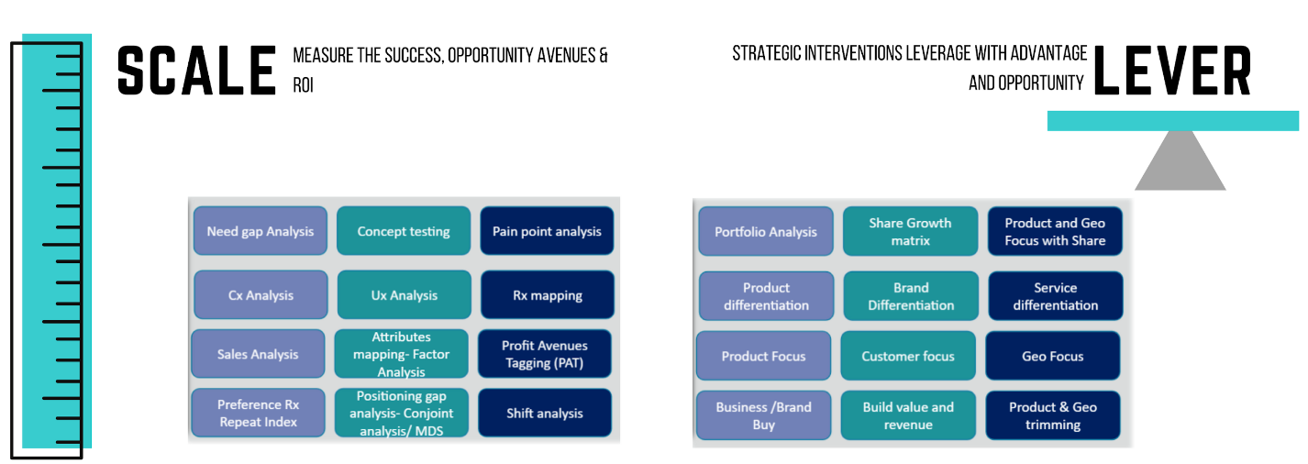

# **OUR GOAL:**



**INDUSTRIES SERVED:**

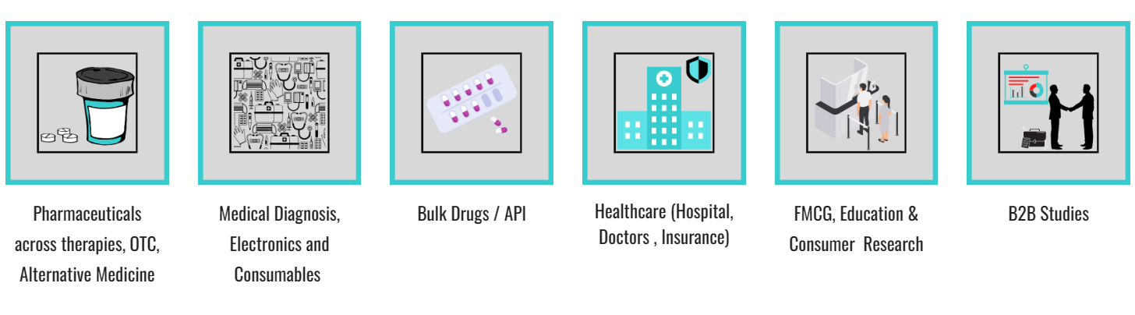

**DELIVERABLES:**

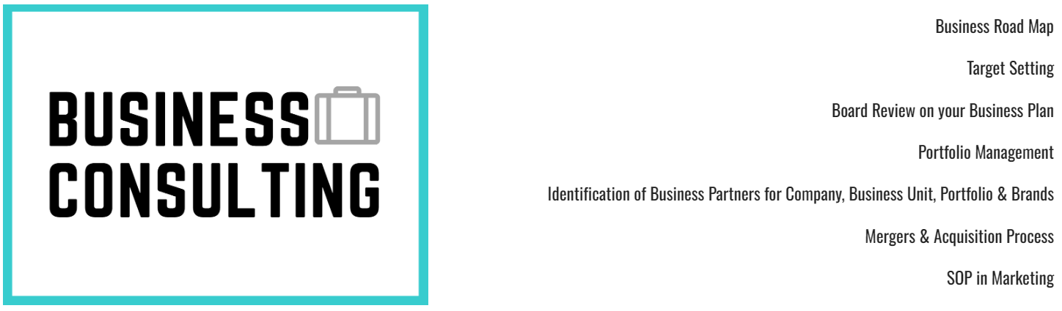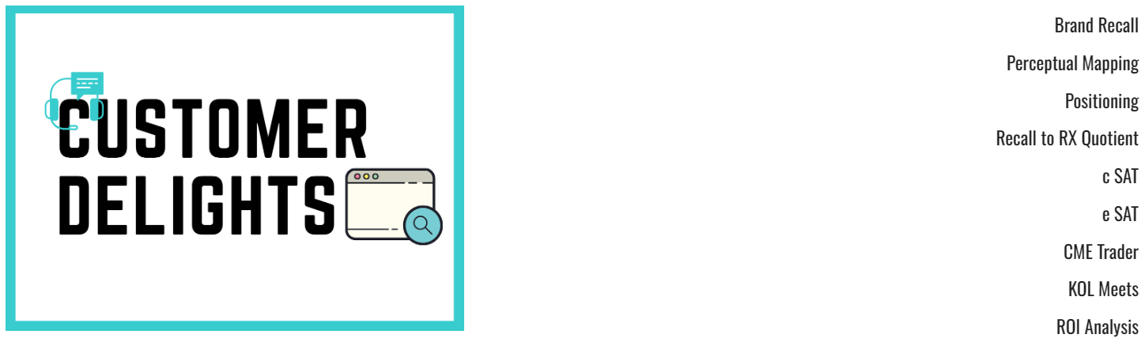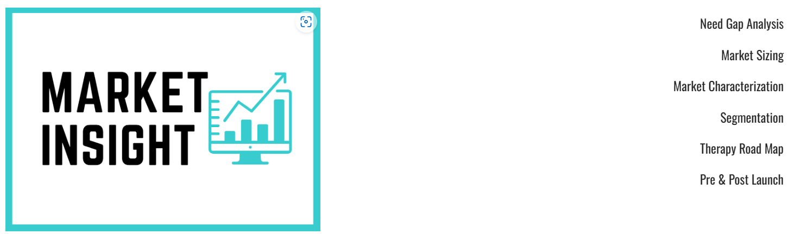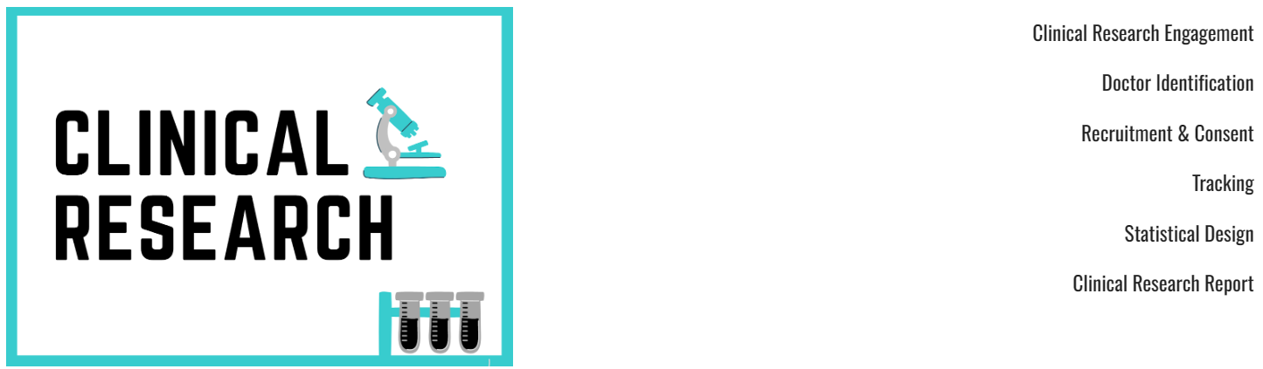

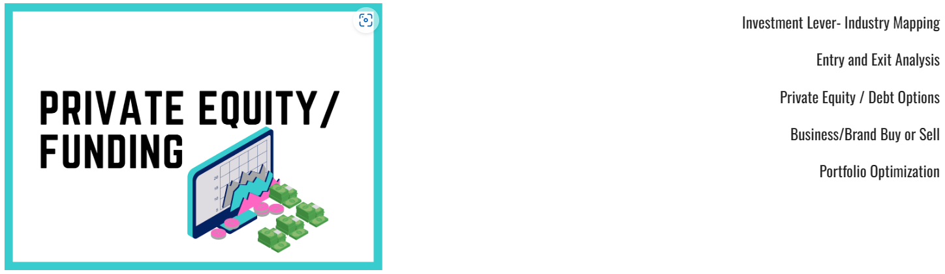

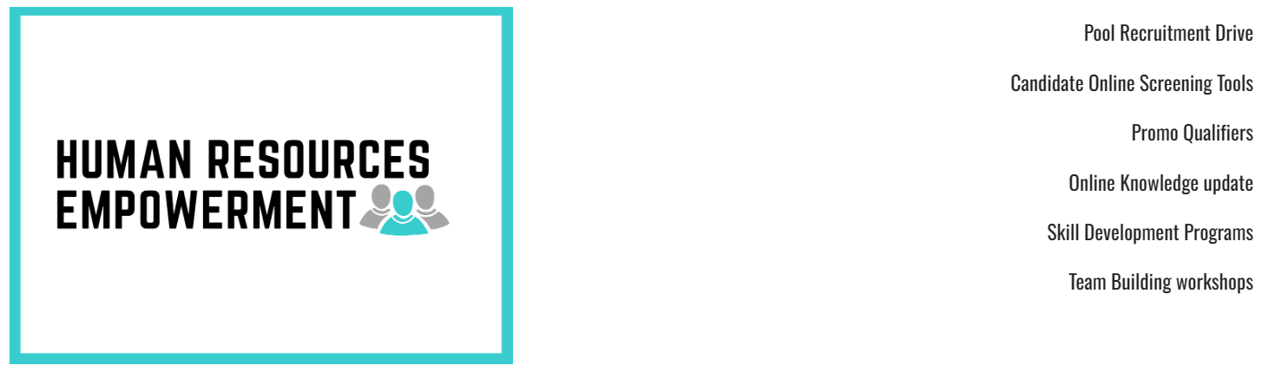

**We serve a range of industries from Healthcare to Medical Electronics, Pharmaceuticals to Bulk drugs, OTG to FMCGs , B2B to B2C studies and all speciality care research & analytics assignments.**

#### **Company Details**

#### 

**How its works:**

A pharmaceutical marketing company is responsible for promoting and distributing pharmaceutical products to healthcare professionals, hospitals, pharmacies, and, in some cases, directly to consumers. Here is an overview of how a pharmaceutical marketing company typically operates:

**1. Product Selection and Licensing:**

- Pharmaceutical marketing companies may either develop their own drugs or acquire the rights to market and distribute existing products. This can involve licensing agreements with drug manufacturers or in-house research and development.

**2. Market Research and Analysis:**

- The company conducts thorough market research to understand the demand for specific drugs, target demographics, competition, and regulatory requirements. This helps in shaping the marketing strategy.

**3. Regulatory Compliance:**

- Ensuring compliance with local and international regulatory bodies is crucial. This includes obtaining necessary approvals, licenses, and adhering to advertising and labeling guidelines.

**4. Product Positioning and Branding:**

- The company determines how to position the product in the market, considering factors like its unique selling points, intended use, and target audience. They also establish branding elements such as name, packaging, and visual identity.

**5. Distribution and Supply Chain Management:**

- Pharmaceutical marketing companies establish relationships with wholesalers, retailers, hospitals, and pharmacies to ensure efficient distribution of their products. They manage logistics, inventory levels, and replenishment processes.

**6. Sales Force and Representatives:**

- These companies often employ a dedicated sales force comprising medical representatives or sales representatives. These individuals visit healthcare professionals, present the products, provide information, and facilitate sales.

**7. Healthcare Professional Education and Promotion:**

- The marketing company conducts educational programs, seminars, and workshops to update healthcare professionals about the benefits and usage of their products. They provide scientific literature and samples as well.

**8. Marketing Collateral and Materials:**

- They create promotional materials, including brochures, visual aids, and digital presentations, to support their sales representatives in effectively communicating product information.

**9. Advertising and Promotions:**

- Pharmaceutical marketing companies engage in various forms of advertising, including medical journals, websites, conferences, and sometimes direct-to-consumer advertising, if permitted by regulations.

**10. Compliance with Ethical Guidelines:**

- They must adhere to ethical guidelines and codes of conduct set by industry associations and regulatory authorities, ensuring that marketing practices are responsible and truthful.

**11. Post-Marketing Surveillance and Pharmacovigilance:**

- Monitoring for adverse events, tracking product effectiveness, and reporting any safety concerns to regulatory agencies is a critical responsibility.

**12. Market Expansion and Global Reach:**

- Depending on their scale and reach, pharmaceutical marketing companies may expand into international markets. This involves understanding and complying with different regulatory environments.

**13. Data Analytics and Market Insights:**

- They may employ data analytics to track sales trends, customer preferences, and other key performance indicators. This information helps in refining marketing strategies.

**14. Compliance with Intellectual Property Laws:**

- Pharmaceutical marketing companies must respect intellectual property rights, especially in cases where they are marketing products developed by other companies.

**15. Engagement with Key Opinion Leaders (KOLs):**

- Building relationships with healthcare experts and key opinion leaders can help in gaining credibility and influence within the medical community.

**16. Market Research:**

- Pharmaceutical companies conduct extensive market research to understand the needs of healthcare providers, patients, and the competitive landscape. This helps them tailor their marketing efforts and develop products that meet specific market demands.

**17. Brand Positioning and Messaging:**

-Creating a strong brand identity and defining clear messaging is crucial in pharmaceutical marketing. Companies work to differentiate their products from competitors and highlight the unique benefits and features of their medications.

**18. Conference Sponsorship and Exhibitions:**

- Pharmaceutical companies often sponsor and exhibit at medical conferences and trade shows. These events provide opportunities to showcase their products, engage with healthcare professionals, and stay updated on industry trends.

**19. Digital Marketing and Social Media:**

-In recent years, digital marketing has become increasingly important in pharmaceutical marketing. This includes strategies like search engine optimization (SEO), pay-per-click advertising, social media marketing, and content marketing to reach a wider audience online.

**20. Patient Advocacy and Support Groups:**

-Some pharmaceutical companies collaborate with patient advocacy organizations to support patients dealing with specific medical conditions. This can involve providing resources, organizing events, and funding research initiatives.

**21. Lobbying and Advocacy Efforts:**

- Pharmaceutical companies may engage in advocacy efforts to shape healthcare policies and regulations that affect their industry. They may work with industry associations and lobbyists to influence government decisions.

**22. Real-World Evidence and Health Economics Outcomes Research (HEOR):**

-In addition to clinical trial data, pharmaceutical companies may conduct real-world studies to demonstrate the effectiveness, safety, and cost-effectiveness of their products in real-world settings.

**23. Continuing Medical Education (CME) Programs:**

- Pharmaceutical companies often sponsor or provide funding for educational programs and courses for healthcare professionals. These programs help healthcare providers stay updated on the latest medical advancements.

**24. Global Expansion and Market Access:**

-Pharmaceutical companies work to gain regulatory approvals and market access in different countries. This involves navigating various regulatory pathways and ensuring compliance with local laws and standards.

**25. Risk Management and Safety Communications:**

-Companies are responsible for monitoring and communicating any new safety information or warnings about their products to healthcare professionals, patients, and regulatory agencies.

**26. Measuring and Analyzing Campaign Effectiveness:**

-Pharmaceutical companies use various metrics and analytics tools to assess the success of their marketing efforts. This includes tracking sales data, monitoring website traffic, and evaluating the impact of different promotional activities.

**Advantages :**

It's important to note that pharmaceutical marketing companies operate within a highly regulated industry and are subject to stringent guidelines to ensure the safety and efficacy of pharmaceutical products. They play a crucial role in connecting manufacturers with healthcare providers and patients, ultimately facilitating access to important medications.

There are several advantages associated with pharmaceutical marketing, both for the companies involved and for the healthcare system as a whole:

1. **Increased Awareness and Education:**

Pharmaceutical marketing helps raise awareness about medical conditions and available treatment options. It educates healthcare professionals and patients about the benefits and risks of different medications.

1. **Medical Innovation and Research Funding:**

The revenue generated from successful pharmaceutical marketing efforts can be reinvested into research and development, driving innovation in healthcare and leading to the discovery of new and improved treatments.

1. **Improved Patient Outcomes:**

Effective pharmaceutical marketing can lead to better patient adherence to prescribed medications. This can result in improved health outcomes and a better quality of life for patients.

1. **Faster Access to New Treatments:**

Marketing efforts can help speed up the availability of new and potentially life-saving treatments to patients. This can be especially critical in cases of serious or rare diseases.

1. **Economic Benefits:**

The pharmaceutical industry is a significant contributor to the economy, providing jobs, generating tax revenue, and stimulating economic growth in the regions where these companies operate.

1. **Competitive Environment:**

Competition within the pharmaceutical industry encourages companies to strive for excellence and innovation. This can lead to the development of more effective and efficient treatments.

1. **Global Health Impact:**

Pharmaceutical companies often have a global presence, which means their products can have a positive impact on health outcomes around the world.

1. **Support for Patient Access Programs:**

Many pharmaceutical companies offer patient assistance programs to help individuals afford their medications, ensuring that those in need have access to necessary treatments.

1. **Funding for Medical Education and Research:**

Pharmaceutical companies often provide funding for medical education, research grants, and other initiatives that contribute to advancements in medical science and patient care.

1. **Disease Awareness Campaigns:**

Pharmaceutical marketing can include disease awareness campaigns, which aim to educate the public about specific health conditions, their symptoms, and available treatment options.

1. **Regulatory Oversight and Safety Monitoring:**

The pharmaceutical industry is heavily regulated to ensure that products meet rigorous safety and efficacy standards. Marketing practices are subject to strict scrutiny to protect patient safety.

1. **Investment in Rare and Neglected Diseases:**

Pharmaceutical companies may invest in research and development for rare diseases or conditions that might not receive as much attention otherwise.

Certainly, here are some additional disadvantages and criticisms associated with pharmaceutical marketing:

1. **Influence on Research and Clinical Trials:**

Some critics argue that pharmaceutical companies may have undue influence on the design, conduct, and reporting of clinical trials. This can potentially lead to biased or selectively reported results.

1. **Limited Focus on Preventive Medicine:**

Pharmaceutical marketing often emphasizes treatment of existing conditions, sometimes at the expense of promoting preventive measures or lifestyle changes that could reduce the need for medication.

1. **Limited Investment in Certain Therapeutic Areas:**

There may be less marketing and research focus on less profitable therapeutic areas, especially those affecting smaller patient populations.

1. **Accessibility and Affordability Concerns:**

High drug prices, coupled with insurance coverage limitations, can lead to barriers in access for some patients, potentially compromising their ability to receive necessary medications.

1. **Waste and Environmental Impact:**

Packaging, production, and distribution of pharmaceutical products can have environmental consequences, including waste generation and potential water pollution.

1. **Lack of Comparative Effectiveness Data:**

In some cases, aggressive marketing can overshadow efforts to conduct rigorous comparative effectiveness research, which can provide valuable information on the relative benefits of different treatment options.

1. **Influence on Clinical Guidelines:**

Some argue that pharmaceutical marketing can potentially influence the development of clinical guidelines and treatment protocols, which may not always be solely based on scientific evidence.

1. **Litigation and Product Liability:**

Aggressive marketing practices can sometimes lead to legal challenges, particularly if there are allegations of false or misleading claims about a product's effectiveness or safety.

1. **Public Perception and Trust Issues:**

High-profile cases of unethical marketing practices or safety concerns can erode public trust in the pharmaceutical industry as a whole.

1. **Ethical Concerns:**

Critics may raise ethical questions about the prioritization of profits over patient welfare, especially in cases where life-saving medications are priced at levels that make them inaccessible to many.

1. **Stress on Healthcare Systems:**

The introduction of new, heavily marketed medications can strain healthcare systems, as providers and payers need to adapt to new treatments, potentially leading to increased costs.

It's important to note that while there are clear benefits to pharmaceutical marketing, it also comes with responsibilities. Ethical marketing practices and adherence to regulatory guidelines are crucial to ensure that patient safety and well-being remain at the forefront of all efforts. Additionally, transparency and open communication with healthcare professionals and the public are essential elements of responsible pharmaceutical marketing.

**Disadvantages** **:**

While pharmaceutical marketing has its advantages, it also comes with a set of potential disadvantages and criticisms. Here are some of the drawbacks associated with pharmaceutical marketing:

1. **High Drug Prices:**

Critics argue that aggressive marketing practices can contribute to high drug prices, as companies may need to recoup the costs of extensive marketing campaigns.

1. **Overemphasis on Profit:**

Some critics believe that the focus on marketing and profit margins can lead to a prioritization of financial interests over patient well-being.

1. **Overprescribing and Overuse:**

Aggressive marketing tactics may lead to overprescribing of medications, sometimes for conditions where alternative treatments or non-pharmaceutical approaches might be equally or more effective.

1. **Direct-to-Consumer (DTC) Advertising Concerns:**

DTC advertising can sometimes lead to patients requesting specific medications from their healthcare providers based on advertising they have seen, potentially influencing medical decisions.

1. **Conflicts of Interest:**

Interactions between pharmaceutical companies and healthcare professionals may raise concerns about conflicts of interest. Gifts, sponsorships, and other incentives can potentially influence treatment decisions.

1. **Inaccurate or Misleading Information:**

There have been instances of misleading or incomplete information in pharmaceutical marketing materials. This can lead to misunderstandings about the benefits, risks, and appropriate use of medications.

1. **Pressure on Healthcare Providers:**

Healthcare providers may feel pressured or influenced by pharmaceutical representatives, potentially impacting their prescribing decisions.

1. **Promotion of "Me-Too" Drugs:**

Some critics argue that marketing resources are disproportionately directed towards promoting minor variations of existing drugs (often referred to as "me-too" drugs) rather than truly innovative treatments.

1. **Unintended Consequences:**

The push for aggressive marketing can sometimes lead to unintended consequences, such as the promotion of off-label uses of medications or the downplaying of potential side effects.

1. **Erosion of Trust:**

Overly aggressive or misleading marketing practices can erode trust between pharmaceutical companies, healthcare providers, and patients.

1. **Resource Allocation:**

Critics argue that the substantial resources spent on marketing could potentially be redirected towards research and development, or towards making medications more affordable and accessible.

1. **Regulatory Compliance Challenges:**

The pharmaceutical industry operates under strict regulations, and companies must devote significant resources to ensure compliance with evolving legal and ethical standards.

It's important to note that the pharmaceutical industry, along with regulatory bodies and healthcare professionals, actively addresses these concerns. Ongoing efforts aim to strike a balance between the benefits of pharmaceutical marketing and the need to ensure ethical, transparent, and patient-centered practices. This includes initiatives to improve transparency, enhance regulatory oversight, and promote evidence-based decision-making in healthcare.

**CHAPTER VI**

**ANNEXURE**

**A Case Study on Marketing Strategies of the Pharma Industry with Reference**

I. Introduction:-

The Indian pharmaceutical sector has come a long way, being almost non-existent before 1970 to a prominent provider of healthcare products, meeting almost 95 per cent of the country's pharmaceuticals needs. The industry today is in the front rank of India‟s science-based industries with wide rangingcapabilities in the complex field of drug manufacture and technology. It ranks very high inthe third world, in terms of technology, quality and range of medicines manufactured. Fromsimple headache pills to sophisticated antibiotics and complex cardiac compounds, almost every type of medicine is now made indigenously.

It is playing a key role in promoting and sustaining development in the vital field of medicines, TheIndian Pharmaceutical Industry boasts of quality producers and many units approved by regulatory authorities in USA and UK. International companies associated with this sector have stimulated, assisted and spearheaded this dynamic development in the past 53 years and helped to put India on the pharmaceutical map of the world. The Indian pharmaceutical sector is fragmented with more than 20,000 registered units with severe price competition and government price control. It has expanded drastically in the last two decades.

There are about 250 large units that control 70 per cent of the market with market leader holding nearly 7 per cent of the market share and about 8000 small scale units together which form the core of the pharmaceutical industry in India (including 5 central public sector units). These units produce the complete range of pharmaceutical formulations, i.e., medicines ready for consumption by patients and about 350 bulk drugs, i.e., chemicals having therapeutic value and used for production of pharmaceutical formulations.

Following the de-licensing of the pharmaceutical industry, industrial licensing for most of the drugs and pharmaceutical products has been done away with. Manufacturers are free to produce any drug duly approved by the drug control authority. Technologically strong and totally self-reliant, the pharmaceutical industry in India has low costs of production, low R&D costs, innovative scientific manpower, strength of national laboratories and an increasing balance of trade. The total Indian production constitutes about 13 per cent of the world market in value terms and, 8 per cent in volume terms.In all its activities the pharmaceutical industry believes that high standards should be defined and respected and is convinced that, so far as its marketing activities are concerned, self- discipline is the process which best serves the public interest.

India is getting recognition as a strong, and fast growing economy. Thus the industry is attracting many global entrants. Increasing purchasing power of the growing middle class population, high orientation towards health consciousness, quality and price driven mindset have reshaped the market structure of pharmaceutical business. The behavior and bargaining power of different interest groups like patients, healthcare providers and regulatory authorities are expected to reinforce sect oral growth and scope. Smilax is a genus of about 200 species of climbing flowering medicinal plants. Smilax is a vine that bears flowers and berries with many useful therapeutically properties. It is commonly known as „Sarsaparilla.‟ Smilax is a 100 crores turnover company and is a research driven, vertically integrated pharmaceutical manufacturing company that manufactures Active Pharmaceutical Ingredients (APIs), API Intermediates and NDDS/Pellets for the global generics market.Smilax has incepted its journey in the world of Pharmaceuticals during the year 2005. Within three years Smilax has become a reliable supplier of its products across the globe because of its Quality of products and Customer Service.Smilax is extending its foot prints in the world of pharmaceuticals day by day

**II. Current Scenario**

India's US$ 9.4 billion pharmaceutical industry is growing at the rate of 14 percent per year. It is one of the largest and most advanced among the developing countries. The Indian pharmaceutical industry can reach a market size of US$ 11.6 billion by 2009. A beginning has been made with the signing of General Agreement on Tariffs and Trade in January 2005 with which India began recognizing global patents. Soon after, the Indian pharmacy market became a sought after destination for foreign players. Foreign direct investment into the country‟s pharmacy industry touched US$ 172 million during 2005-06 having grown at a CAGR of 62.6 per cent during the period beginning 2002-06. The sector recorded strong growth in the second quarter ended September 2006, driven by launch of new generic drugs with 180 days exclusivity period in the US market. The top ten pharmacy companies reported an impressive 57 per cent growth in consolidated net profit at US$ 314.3 million, as against US$ 200.7 million in the same quarter of the previous year, while consolidated net sales were up 51 per cent at US$ 1.7 billion. There are 74 U.S. FDA-approved manufacturing facilities in India, more than in any other country outside the U.S, and in 2005, almost 20 per cent of all Abbreviated New Drug Applications (ANDA) to the FDA were filed by Indian companies. Growth in other fields notwithstanding, generics is still a large part of the picture. London research company Global Insight estimates that India‟s share of the global generics market will have risen from 4 per cent to 33 per cent by 2007. The focus of the Indian pharmaceutical companies is also shifting from process improvisation to drug discovery and R&D. the Indian companies are setting up their own R&D setups and are also collaborating with the research laboratories like CDRI, IICT etc.

**III. Scope Of The Study.**

The Scope of the study focuses on the marketing strategies followed by Smilax labs for its marketing activities. The study concentrates on the methods and techniques followed by the company which include the standard operating procedure, Export procedure & Benefits at smilax laboratories The study appraises the company‟s success in meeting requirement of the company and supplying the modernized and innovated medical equipment and drugs to the world. The data required for the study is collected from the past year published annual reports of the company.

**Need For The Study.**

The study is intended to know the marketing strategies of the company. Since, the company growth depends upon their sales conditions only. The study mainly deals with the marketing activities of the company. The main objective of the study is to know how the company performs its marketing activities for the attainment of its goals. The study covers the standard operating procedure, exporting and benefits, types of markets available for the smilax labs.

**Objectives Of The Study**

The following basic objectives are under below

To study the present standard operating procedure of the smilax labs.

To study procedure for exporting and the benefits of the exporting of the smilax labs.

To study Different types of markets available to sell the products.

To offer valuable suggestions.

1. **Data collection**
2. The success of any research project depends critically on data. So data collection is the most important aspect of the project. Sales data and its comparison with previous financial years.
3. The report from the ICRA about the market potential to assess potential for the companies market.
4. Previous financial year sales as a comparative data to design a strategy to reach company‟s goal.

**b) Market Survey**

Market Survey has been conducted after preparing the checklist and the focus was to know the market share for the company.

We have conducted survey based on IMS data, BDR data and other reports and finally evaluated that there is a very good scope and business opportunity for the product range of smilax laboratories.

**Secondary Data**

Company‟s documents, Brochures, Various journals, pamphlets and companies portals were studied for relevant information regarding the subject of the projects. These documents were very useful for theoretical, conceptual and organizational background. Detailed analysis of information and data collection was carried on and then it has been possible to complete the task.

**Limitation Of The Study**

The export benefit that the company has gained varies from one product to another product so the exact benefit had not been taken.

The benefit from the exports sales is taken only on the average of the sales made in the regulated markets as on 2006 - 2011.

Executives cannot spare enough time for our present work

The organization should maintain a master list of all SOPs. This file or database should indicate the SOP number, version number, date of issuance, title, author, status, organizational division, branch, section, and any historical information regarding past versions. The QA Manager (or designee) is generally the individual responsible for maintaining a file listing all current quality-related SOPs used within the organization. If an electronic database is used, automatic “Review SOP” notices can be sent. Note that this list may be used also when audits are being considered or when questions are raised as to practices being followed within the organization.

**The Pharma Industry**

Pharma Industry The pharmaceutical industry in India is going through a major shift in its business model in the last few years in order to get ready for a product patent regime from 2005 onwards. This shift in the model has become necessary due to the earlier process patent regime put in place since 1972 by the Government of India. This was done deliberately to promote and encourage the domestic health care industry in producing cheap and affordable drugs. As prior to this the Indian pharmaceutical sector was completely dominated by multinational companies (MNCs). These firms imported most of the bulk drugs (the active pharmaceutical ingredients) from their parent companies abroad and sold the formulations (the end products in the form of tablets and capsules, syrups etc.) at prices unaffordable for a majority of the Indian population. This led to a revision of Government of India‟s (GOI) policy towards this industry in 1972 allowing Indian firms to reverse engineer the patented drugs and produce them using a different process that was not under patent.

The entry of MNC‟s was also discouraged by restricting foreign equity to 40%. The licensing policy was also biased towards indigenous firms and firms with lesser foreign equity1. All these measures by GOI laid foundations to a strong manufacturing base for bulk drugs and formulations and accelerated the growth in the Indian Pharmaceutical Industry (IPI), which today consists of more than 20,000 players1. As a result the Indian pharmaceutical industry today not only meets the domestic requirement but has started exporting bulk drugs as well as formulations to the international market. Smilax has the capability of manufacturing APIs and API Intermediates in its state-of-the art manufacturing facilities located in Hyderabad and Visakhapatnam, Andhra Pradesh, India

Currently the main activities of Indian pharmaceutical industry are broadly restricted to producing (i) Bulk drugs and (ii) Formulations with very few companies risking investing in primary research aimed at developing and patenting new drugs. The bulk drug business is essentially a commodity business, where as the formulation business is primarily a market driven and brand oriented business. Multinational companies which have entered the Indian market have mostly restricted themselves to formulation segment till date. The domestic pharmaceutical industry (MNC‟s and Domestic) meets about 90% of the country‟s bulk drug requirement and almost the entire demand for formulations. The economics of bulk drug business and that of formulation business are quite different. Since a majority of the Indian companies are producing both bulk as well as formulations, these are considered together for the purpose of the present study.

The Indian Pharmaceuticals sector has come a long way, being almost non-existing during 1970, to a prominent provider of health care products, meeting almost 95% of country‟s pharmaceutical needs. Indian pharmaceutical sector is one of the fastest growing sectors. Initially India had to wait for imports of bulk drugs from global majors for re-processing and now it has become an industry which is driving product development and breaking new ground in medicine research worldwide. Indian pharmaceutical industry is undergoing fast paced changes. The Indian Generics market is witnessing rapid growth opening up immense opportunities for firms. This is further triggered by the fact that generics worth over $40(1820) billion are going off patent in the coming few years which is close to 15% of the total prescription market of the US. The Indian pharmaceutical companies have been doing extremely well in developed markets such as US and Europe, notable among these being Ranbaxy, Dr. Reddy‟s Labs, Wockhard, Cipla, Nicholas Piramal and Lupin. The companies have their strategies in place to leverage opportunities and appropriate values existing in formulations, bulk drugs, generics, Novel Drug Delivery Systems, New Chemical Entities, and Biotechnology etc. The industry ranks fourth globally in terms of volume and in terms of value, it is ranked thirteenth. The industry has thrived so far on reverse engineering skills exploiting the lack of process patent in the country. This has resulted in the Indian pharmaceutical players offering their products at some of the lowest prices in the world. The quality of the products is reflected in the fact that India has the highest number of manufacturing plants approved by US FDA, which is next only to that in the US. Multinational companies have traditionally dominated the industry, which is another trend seeing a reversal. Currently, it is the Indian companies which are dominating the marketplace with the local players dominating a number of key therapeutic segments. The market is also very fragmented with about 30,000 entities and the organized sector consisting of about 300 entities. Consolidation is increasing in the industry with many local players building a global outlook and also growing inorganically through mergers and acquisitions

The average cost of bringing a single new drug to the market is as high as $800(35560) million. Patent protection is more limited than in other industries: because of the lengthy gap between discovery and approval of a new drug, the effective monopoly protection is estimated, since the 1990s, to last only 12 years, apart for extensions. Indeed, according to industry surveys, the only industry in which patents are thought to play an important role in bringing new products to market is the pharmaceutical industry. The pharmaceutical industry is worthy of special consideration also for another, opposite, reason. The technology operated by the pharmaceutical industry – the chemical and industrial processes, through which medicines are produced, packaged, and shipped, seems to fit the constant returns to scale hypothesis almost perfectly. That is, the cost of shipping the ten millionth container of medicine is about the same as that of shipping the first. This is why, after all, everyone complains about the pharmaceutical companies not shipping medicines to poor countries

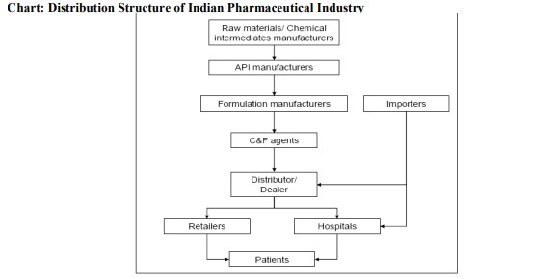

The above illustration depicts the market structure of Indian market. It depicts how the structure is close knit and the system is well connected.

**Pharma Marketing Process And Its Challenges**

While many pharmaceutical companies have successfully deployed a lot of staple strategies to target the various customer types, recent business and customer trends are creating new challenges and opportunities for increasing profitability. In the pharmaceutical and healthcare industries, a complex web of decision-makers determines the nature of the transaction (prescription) for which direct customer (doctor) of pharmaceutical industry is responsible. Essentially, the end-user (patient) consumes a product and pays the cost. Use of medical representatives for marketing products to physicians and to exert some Influence over others in the hierarchy of decision makers has been a time-tested tradition.Typically, sales force expense comprises an estimated 15 percent to 20 percent of annualproduct revenues, the largest line item on the balance sheet. Despite this other expense, the industry is still plagued with some very serious strategic and operational level issues.

**Marketing Strategies Can Be Best Described In These Two Models In Both Chronic And Acute Segments Super Core Mode**

l involving the search for, and distribution of a small number of drugs from Chronic Therapy Area that achieve substantial global sales. The success of this model depends on achieving large returns from a small number of drugs in order to pay for the high cost of the drug discovery and development process for a large number of patients. Total revenues are highly dependent on sales from a small number of drugs. This model incorporates highly specialized approach in all the manner. Initially the competition is seems more at entry level but since growth is stable and more in this area; every company is striving very hard to enter in this area. The major strategy in this model involves right focus to highly specialized customer by well- trained team.

Core Model in which a larger number of drugs from Acute Therapy Area are marketed to big diversified markets. The advantage of this model is that its success is not dependent on sales of a small number of drugs. Here presenting a large number of products and taking the advantage of opportunity cost is one of the important strategies. Other strategy includes daily reminders to cross the perceptual filter and get the brand name in to the sub-conscious state of mind

From organizational perspective the most prominent performance related issues arelisted below:

a) .Increased competition and unethical practices adopted by some of the propaganda base companies.

b). Low level of customer knowledge (Doctors, Retailers, Wholesalers).

c). Poor customer (both external & internal) acquisition, development and Retention strategies

d). Varying customer perception.

e) The number and the quality of medical representatives

d). Very high territory development costs.

f). High training and re-training costs of sales personnel.

g) Very high attrition rate of the sales personnel.

h). Busy doctors giving less time for sales calls.

i). Poor territory knowledge in terms of business value at medical representative level.

j). Unclear value of prescription from each doctor in the list of each sales person.

k). Unknown value of revenue from each retailer in the territory

l). Absence of ideal mechanism of sales forecasting from field sales level, leading to huge deviations m). Absence of analysis on the amount of time invested on profitable and not-so profitable Customers and lack of time-share planning towards developing customer base for future and un-tapped markets.

**Markets Available For The Pharma Busines**

Types of markets for Smilax labs

1. Regulated markets

2. Semi regulated markets

3. Non regulated markets

**Regulated Markets**

Regulated market or controlled market is the provision of goods or services that is regulated by a government appointed body. The regulation may cover the terms and conditions of supplying the goods and services and in particular the price allowed to be charged and/or to whom they are distributed. It is common for a regulated market to control natural monopolies such as aspects of telecommunications, water, gas and electricity supply. Often regulated markets are established during the partial privatization of government controlled utility assets.

In the Pharmaceutical industry, US, Europe and Japan are considered as Regulated markets.

The markets are like USA and Europe

The matured time is about minimum about 3 years

The main works that are in involved are registration filing

Customer visit to our facilities

The price will be premium

**Semi Regulated Markets.**

1. The countries that come under these semi regulated markets are the Korea ,Thailand ,Malaysia ,Egypt ,Mexico ,brazil

2. The time required to complete the regulation and get approvals is 6-12 months.

3. The semi regulatory market contains the limited regulation like registration. 4. Semi regulations countries are like Latin America counties like Brazil, Mexico Argentina,Columbia,and middle east countries Egypt ,Saudi countries ,Africa. 5. The pricing structure will be better from non regulatory markets and lower than regulatory price.

**IV. Analysis**

The graphical representation of total sales denotes that the total sales are high in the year 2009-10 and low in the year 2006-07.

1. The company Smilax laboratories follows the standard operating procedure that are for the
2. • Sales plan of smilax
3. • Generation of the enquiries
4. • Execution of the orders

2. Had been observed and understood and found that the present standard operating procedures need to have some changes in their procedures

3. The company operates in all the markets that regulated ,semi regulated and non regulatedmarkets the standard operating procedures are same for the all these markets

4. The company is getting the benefits of export around 17% - 21% , the regulated markets are difficult to operate but the premium pricing and above that the export benefits are making the market interesting to operate since it is a difficult market that operations in these type of the market is not so easy.

**CONCLUSION :**



The present research affects different dimensions of society. Cosmetic companies, marketers, entrepreneurs and students of business studies are foremost benefited group.Products’ attributes as the key point of selling, to involving celebrities, today it’s mainly about how well a company manages to educate consumers about the personal values, benefits and quality of a product. It’s about being less transactional and more personal. Brands need to provide tools to help consumers validate the individual fit of a product or service for their individual situation.

The research hypothesis suggests that the brand image of the medicine cannot be built by celebrity endorsement. It takes much more to make a medicine brand. The use of celebrity in pharmaceuticals field will increase the cost of promotion mix which will not be good in long run. Companies must focus on other accolades of brand building. Even the legal complexities will reduce the scope of applicability of celebrity endorsements as there are medicines that cannot be sold without prescription.

Though all the goodness of branding of medicines, self-medication is an alarming sign for society. Self-medication must be prevented with the help of clear objectives of branding efforts of medicine. The promotional activities of medicines must also inform the consumer about the importance of medical prescription and disadvantages of self-medication.

The research can be concluded by considering the fact that doctor’s perspective is highly positive on branding strategies of Indian pharmaceutical companies in the context of brand recognition and prescriptions. The significance of present study can be understood as follows:

1. **Pharma companies:**

Pharma companies can use the findings of the study to improve their marketing campaigns. Knowledge about pharmaceutical marketing and branding is empathic if the study is applied to marketing efforts.

1. **Marketers:**

Marketers are not only confined to the knowledge about pharmaceutical marketing and branding but they can use this research for their purposes. Though present study is in the context with knowledge about pharmaceutical marketing and branding but its applicability is in all marketing domains.

1. **Entrepreneurs:**

Starting a venture is difficult as well as easiest task. If all the home work is done in regards of production, supply chain and marketing it is an easy task. Entrepreneurs can access the literature of present research to better equip themselves with knowledge about pharmaceutical marketing and branding tools.

1. **Students of business studies:**

Students of business studies are very dynamic and versatile. They are supposed to be armored with all the academic knowledge to cope up with the forthcoming challenges of business world. Students can enhance their knowledge about pharmaceutical marketing and branding with the help of the literature of present research.

Though all the goodness of branding of medicines, self-medication is an alarming sign for society. Self-medication must be prevented with the help of clear objectives of branding efforts of medicine. The promotional activities of medicines must also inform the consumer about the importance of medical prescription and disadvantages of self-medication. The research can be concluded by considering the fact that doctor’s perspective is highly positive on branding strategies of Indian pharmaceutical companies in the context of brand recognition and prescriptions.

****************************************************